# Media Analysis - ‘I am not here to take your job,’ ChatGPT tells Frankly Speaking host _Updated 20 March 2023

## Short Summary

This article provides an in-depth look at ChatGPT, a conversational AI developed by OpenAI, and its capabilities, limitations, and potential impact on society.

## Summary

This article discusses an interview with ChatGPT, an artificial intelligence language model developed by OpenAI. The interview covers various topics, including:  
  
1. **ChatGPT's capabilities**: The AI model is able to understand and respond to natural language queries, providing information on a wide range of topics, including current events, history, science, and more.  
2. **Role in journalism**: ChatGPT was asked about its potential role in the newsroom, and it acknowledged that while it could provide valuable assistance with research and data analysis, it is unlikely to replace human journalists.  
3. **Israeli-Palestinian conflict**: When asked for its position on the Israeli-Palestinian conflict, ChatGPT replied that it was not appropriate for it to take a stance, instead encouraging dialogue and understanding.  
4. **Integration with Bing search engine**: Microsoft has integrated ChatGPT into its Bing search engine, Edge browser, and other products, which has sparked a competition with Google's Bard AI technology.  
5. **Future developments**: ChatGPT was asked about potential future features, including improvements to the naturalness and sophistication of AI-generated text, as well as incorporating elements like emotion and personality into responses.  
  
Key quotes from the interview:  
  
* "I am not capable of predicting the specific features or capabilities that will be added to ChatGPT in the future..."  
* "...but there are several areas where AI technology is rapidly advancing and where developers may focus their efforts in the near future."  
* "Like any technology, the impact that I have on society will depend on how I'm used in the intentions of those who use me."  
  
Overall, the interview highlights the potential benefits and challenges associated with AI language models like ChatGPT, and emphasizes the need for responsible development and regulation to ensure that these technologies are used for the greater good.

## Question 1

Based on the article, here s how the media in this case, Arab News frames the public discussion about ChatGPT 1. **Technical advancements** The article highlights the latest updates and features of ChatGPT, such as its integration with Microsoft products and the release of GPT-4. 2. **Potential impact on journalism** ChatGPT emphasizes that it is unlikely to replace human journalists in traditional newsrooms or anchors like Frankly Speaking host Katie Jensen. 3. **Concerns about bias and job displacement** The article mentions concerns about the potential negative impacts of AI, including issues related to privacy, bias, and job displacement. 4. **Importance of responsible use and regulation** ChatGPT expresses cautious optimism that its capabilities will be used in a way that promotes the well-being of humanity and contributes to a better future for all. Some metaphors that keep cropping up include 1. ** Force for good or ill ** This metaphor emphasizes the potential dual nature of AI technology like ChatGPT, highlighting both its benefits and drawbacks. 2. ** Tool ** ChatGPT is described as a tool that can be used for various applications, emphasizing its neutral status and the importance of responsible use. 3. ** Becoming a part of human society ** This metaphor suggests that AI technology like ChatGPT is becoming increasingly integrated into human life, with both positive and negative consequences. Overall, the media framing of the public discussion about ChatGPT emphasizes its potential impact on various aspects of human life, including journalism, technology, and society as a whole.

## Question 2

Based on the article, here are some perspectives and aspects of the topic that are being widely covered 1. **Technical advancements** The article discusses the latest updates to ChatGPT, including GPT-4, and its potential applications. 2. **Integration with other technologies** The integration of ChatGPT with Microsoft s Bing search engine, Edge browser, and other products is highlighted as a significant development. 3. **Concerns about bias and job displacement** The article mentions concerns about the potential negative impacts of AI, including issues related to privacy, bias, and job displacement. 4. **Human-AI collaboration** ChatGPT emphasizes its ability to assist humans in various tasks and provide value-added services. Aspects that may be being ignored or underrepresented include 1. **Social implications** While the article mentions concerns about bias and job displacement, it does not delve deeper into the social implications of widespread AI adoption. 2. **Regulatory frameworks** The article does not discuss regulatory frameworks or policies that are in place to govern the development and use of AI technology like ChatGPT. 3. **Critiques of AI s limitations** While ChatGPT highlights its capabilities, it does not address potential limitations or criticisms of AI s performance, such as its reliance on data quality or its inability to understand nuances of human communication. 4. **Diversity and representation in AI development** The article does not discuss the importance of diversity and representation in AI development, including the need for diverse teams and data sets to ensure that AI systems are fair and inclusive. Overall, the article provides a positive and optimistic view of AI s potential benefits, while also acknowledging some of its challenges. However, there may be aspects of the topic that deserve more attention and exploration.

## Question 3

Based on the article, the Arabic world plays a role as a region where Arab News is published, which is mentioned as a leading English-language daily newspaper in Saudi Arabia . There is no mention of the Arabic world leveraging AI specifically. The main focus is on ChatGPT and its capabilities, with Arab News being one of the media outlets that interviewed it.

## Question 4

The final message of the article is that the impact of AI, specifically ChatGPT, on society depends on how it s used, and it s essential for developers, policymakers, and users to work together to ensure its benefits are maximized while mitigating potential negative consequences.

## Sentiment

The sentiment is 1.0

## Entities

AI, Bing, Jensen, Edge, ChatGPT, OpenAI, Google, Baidu, Bard, Amazon, Frankly Speaking, Meta, Arab News, Katie Jensen, Sam Altman, Microsoft

## Highlights

#c885da: 29

#f9cd59: 20

#7cc867: 65

#fb5b89: 50

#69aff0: 7

## Wordcloud for #c885da Highlights

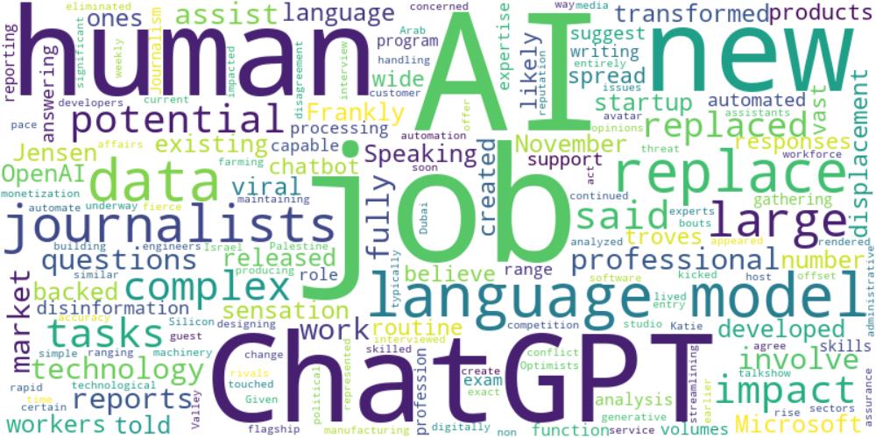

Top 10 words:

- AI: 18

- jobs: 10

- language: 10

- ChatGPT: 9

- human: 9

- job: 7

- data: 7

- replace: 7

- journalists: 7

- large: 6

## Wordcloud for #f9cd59 Highlights

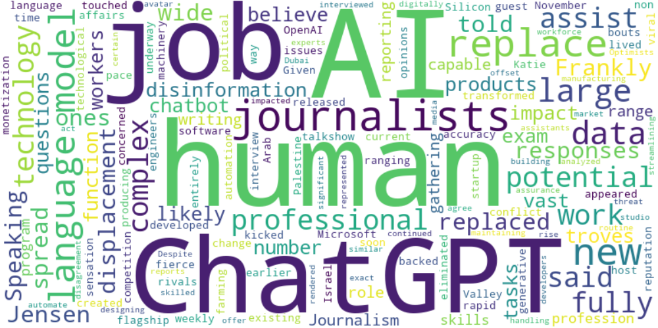

Top 10 words:

- AI: 10

- human: 9

- ChatGPT: 7

- journalists: 7

- language: 6

- replace: 6

- jobs: 4

- large: 4

- data: 4

- like: 3

## Wordcloud for #7cc867 Highlights

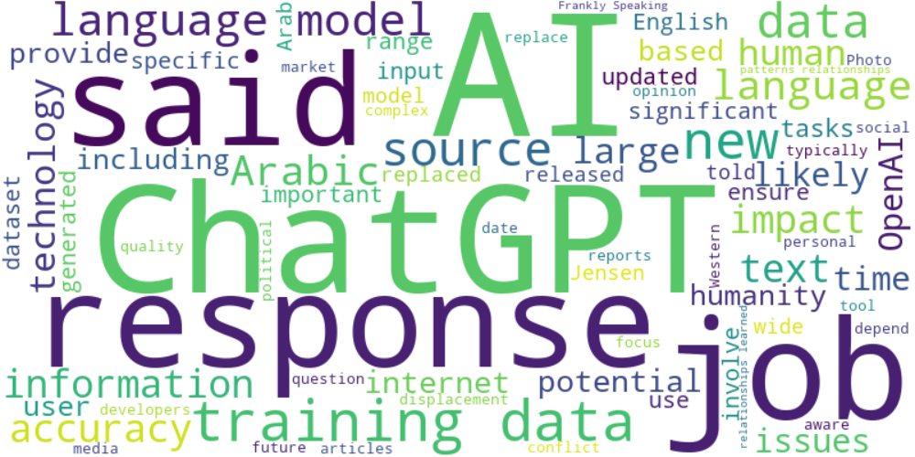

Top 10 words:

- AI: 27

- data: 24

- ChatGPT: 20

- language: 18

- training: 16

- responses: 14

- said: 14

- jobs: 9

- sources: 9

- new: 8

## Wordcloud for #fb5b89 Highlights

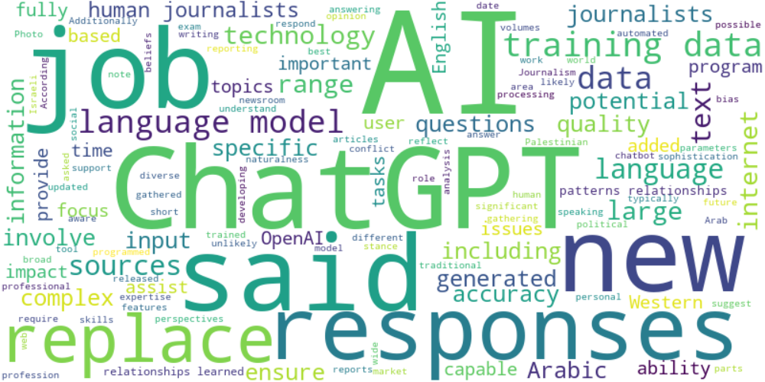

Top 10 words:

- AI: 22

- data: 17

- language: 14

- ChatGPT: 13

- said: 11

- responses: 10

- training: 10

- replace: 9

- journalists: 8

- jobs: 7

## Wordcloud for #69aff0 Highlights

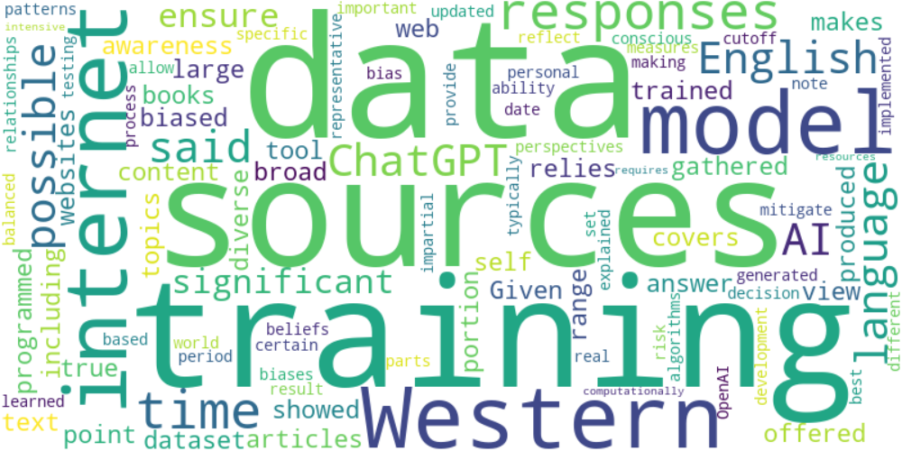

Top 10 words:

- data: 5

- sources: 4

- training: 4

- Western: 3

- internet: 3

- model: 3

- responses: 3

- time: 3

- English: 2

- possible: 2